Doing Business in India: Opportunities for Australian Services Firms

Thursday 25 August 2016, 7:30am – 9:30am

Speaker Biographies

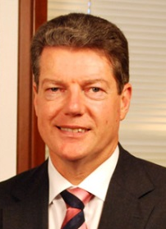
Stuart Davis, LLB (Adelaide)

Until mid-2012, Stuart was Chief Executive Officer of the Hong Kong and Shanghai Banking Corporation (HSBC) in India (appointed April 2009), with responsibility for 8,000 employees, $1b in revenue and a $17b balance sheet.

He was previously Chief Executive Officer of HSBC Bank Australia from 2002 until his India appointment. From 1999 to 2002 Stuart was Chief Executive Officer of HSBC Taiwan, where he was responsible for HSBC’s local personal and commercial banking operations.

He is currently Chairman, South Asia Forum Ltd, and Non-Executive Director, Next DC.

Neelesh Mehta - Co-founder & Managing Director, Jaipur AM

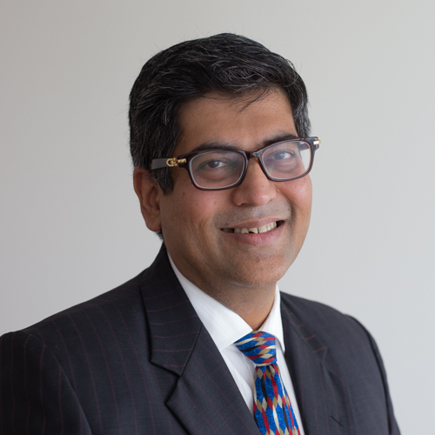
Neelesh brings a breadth and depth of experience in capital markets and financial services in South-East Asia, particularly India, and in Australia. His experience spans mergers and acquisitions; investments; capital raisings; corporate restructuring; finance; governance and treasury management.

As a senior executive in dominant (top 10) broking houses in India, Neelesh managed investments on behalf of many of India’s ultra-high net worth individuals and corporate houses. He also helped establish more transparent and robust governance and operating procedures.

Since moving to Australia in 2004, Neelesh has been Chief Financial Officer and Finance Director of a number of organisations where he has continued to provide strategic and financial advice and manage corporate investments across various markets.

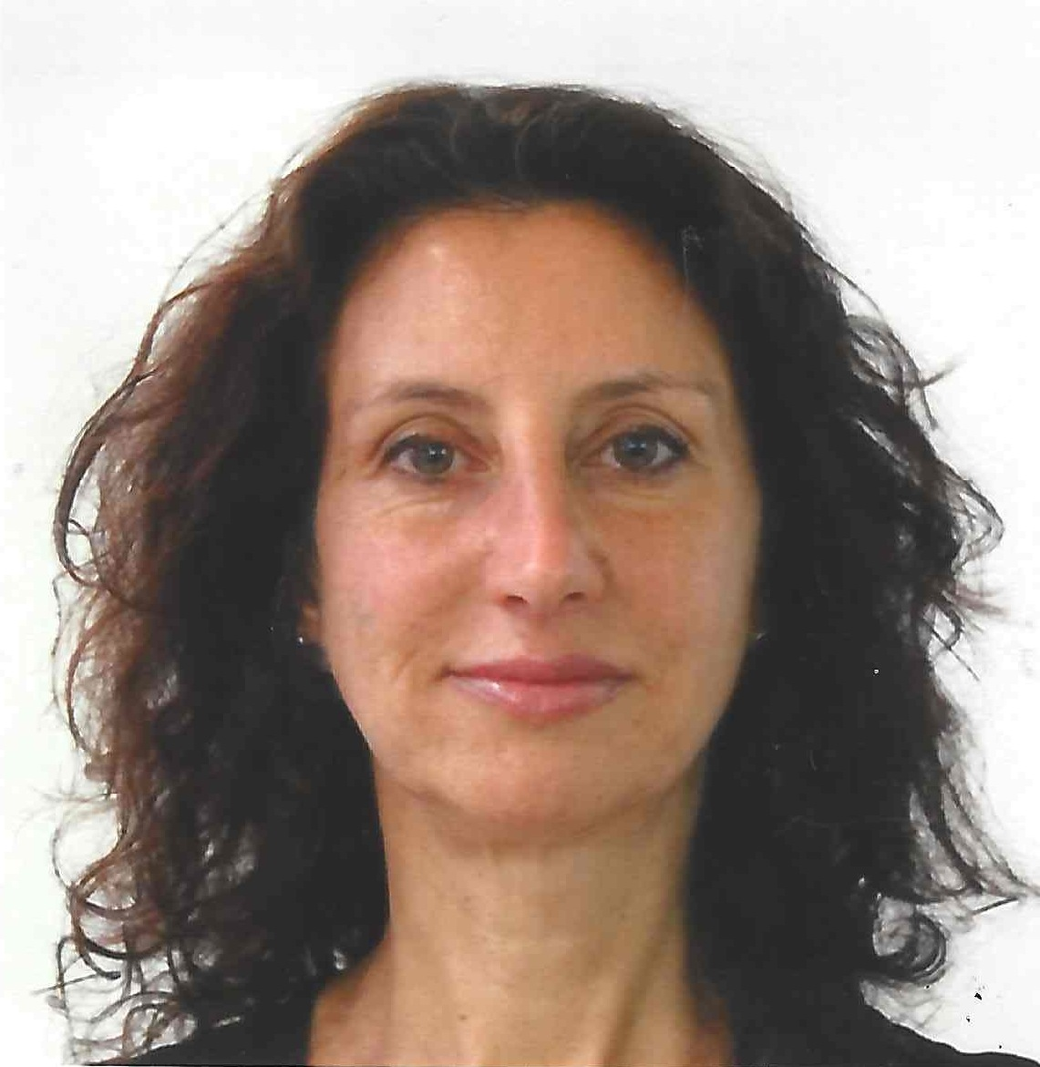
Loretta Joseph - Director of Market Development, Sydney Stock Exchange

Loretta is a highly dynamic, skilled banking, financial and consulting professional with over 25 years in financial markets and related sectors. She has a worked for major investment banks at Board, MD or senior management level throughout Asia and India including, RBS (India), Macquarie Group (India), Deutsche Bank, Credit Suisse and Elara Capital (India).

Spanning a long career, Loretta has tremendous exposure to global financial markets, multiple asset classes and emerging market environments. Loretta has advised many international banks, global hedge and pension funds on managing portfolio and exposure to derivatives and related products.

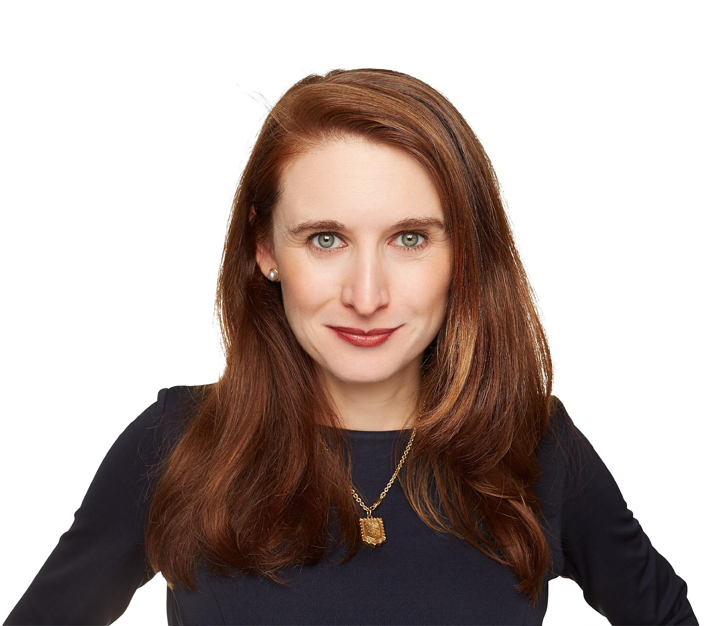

Moderator - Cynthia Dearin - Managing Director, Dearin & Associates

Cynthia works with business owners and decision-makers to help them access opportunities and capital in international markets. She has excellent expertise and contacts in cross cultural communication and commercial intelligence. Cynthia is Managing Director of Dearin & Association, a Board member of the ASR and Chair of The Boardroom.com. Cynthia is fluent in Arabic and French.

