MEMBERSHIP APPLICATION FORM

1. COMPANY DETAILS |  |  | 3. MEMBERSHIP RATES
Company name: …………………………………………………………………………….. |  |  | The membership period is 12 months from the date of joining and covers all employees within your organization. Rates payable are determined by whether you are a corporate of an industry association.  CORPORATE: member rates are based on number of employees  ASSOCIATION: member rates are based on number of members for individual member based organisations or annual revenue for other associations.
ABN: ………………………………………………………………………………………………..

Street Address: ………………………………………………………………………………..

Suburb: ……………………………………………………………………………………………

State: ………………………………….............. Postcode: …………………………… |  |  | 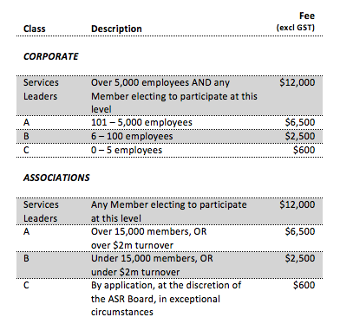
Tel: ( ……………) ……………………………………………………………………………….

Company Website: …………………………………………………………………………

Services Sector: ……………………………………………………………………………….

Specific Areas of Interest:

Domestic ☐  Policy | International ☐  Policy | Innovation ☐
2. PRIMARY CONTACT

Title: ………………………………………………………………………………………………..

Name: …………………………………………………………………………………………….. |  |  | 4. PAYMENT DETAILS
Job Title: …………………………………………………………………………………………. |  |  | Total ……………………………….…………………………...…… (inc GST)
Email: ……………………………………………………………………………………………… |  |  | Preferred method of payment:
Direct Line: ( ……………) …………………………………………………………………… |  |  | Invoice ☐ | Credit Card ☐ | Direct ☐  Bank Transfer
Mobile: ……………………………………………………………………………………………  Additional Contacts: See Attached |  |  | Please email this completed form to the Australian Services Roundtable alinabain@australianservicesroundtable.com.au  if you have any questions please call ASR CEO Alina Bain on 0400 202 804

ADDITIONAL CONTACTS

Please include contact details for Primary Contact’s EA

 | Name | Position | Location (City/Country) | Email | Contact No.

